The Commonwealth of Massachusetts
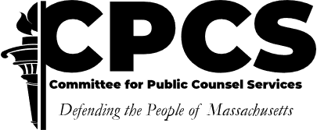
Committee for Public Counsel Services

Alternative Commitment & Registration Support Unit

75 Federal Street, 6th Floor Boston, MA 02110

TEL: 617-482-6212
FAX: 617-502-6328

ANTHONY J. BENEDETTI VANESSA VELEZ
CHIEF COUNSEL DEPUTY CHIEF COUNSEL
PRIVATE COUNSEL DIVISION

Request for Waiver of Bar Advocate Membership
SDP Trials and SORB Hearings

Return to: ac@publiccounsel.net or mail to Assignment Coordinator at above address
Name____________________________________________________________________________________

Address__________________________________________________________________________________

Telephone________________________________________________________________________________

Email____________________________________________________________________________________

- The Committee for Public Counsel Services is committed to assuring that the panel of attorneys accepting assignments is sensitive to the diversity of the indigent population it serves. What background, experience and perspectives would you bring to the panel which would further the goals of having a diverse panel that provides high quality legal representation to an indigent population?

- Does a prosecutor's office, other law enforcement agency or administrative agency currently employ you, either as a volunteer or salaried employee, full or part-time?

- Please list six jury trials tried to verdict within the last 5 years.

- Please list all additional criminal and civil trials tried to verdict, indicating whether before a jury or judge, within the last 5 years.

- Please list all administrative law hearings you have conducted or litigated within the last 5 years.

- Please state the reasons why you seek to become certified to accept SDP and/or SORB assignments.

- Please furnish any other information which you think would be helpful to the evaluation of your application, including why you are not currently a member of a bar advocate program.

- If you wish to submit statements from references, please attach.

Statement and Signature

I hereby certify that the above and attached information is true and correct.

Date_______________________ Signature____________________________________________

