Resources: Covid-19
As of 3/30/2020
C. Dunne & YAD SSA’S

General

Mass 211: https://mass211.org/ or Call 2-1-1

Provides information about critical health and human services available in their community. It serves as a resource for finding government benefits and services, nonprofit organizations, support groups, volunteer opportunities, donation programs, and other local resources. Multi-lingual, confidential info on resources. Currently experiencing heavy volume of calls. Available 24/7.

Project Bread: http://www.projectbread.org/news-and-events/news/covid-19-hunger-food.html
For families and households in Massachusetts needing food assistance during this challenging time. Resources will be updated as more information becomes available.

Food Source Hotline: 1-800-645-8333

Find School Meal Sites & Info:

https://docs.google.com/spreadsheets/d/1gcj-hEqLnqdpn1M6j74fKpgjdQ1F2O6XxVvwcvDkQYI/edit#gid=0

Mass Network of Care: https://massachusetts.networkofcare.org/mh/index.aspx

A directory of over 5,000 mental health and substance use programs and organizations across the Commonwealth, searchable by keyword and zip code.

Health Insurance Coverage: A special enrollment period is now open to get currently uninsured MA residents on health insurance plans. This will help ensure folks get proper treatment should they become infected. Special enrollment is open now through April 25.

Mass Health Info: https://www.mass.gov/topics/masshealth

Mass Health Connector: www.mahealthconnector.org (To apply for Health Insurance)

FAQ’s Re Mass Health & Covid: https://www.mass.gov/info-details/masshealth-coronavirus-disease-2019-covid-19-applicants-and-members

Information on Covid-19: Multi-lingual google docs

https://www.mass.gov/info-details/covid-19-printable-fact-sheets

Meals For Students

Meals4Kids: Massachusetts School Closures & Meal Distribution
https://meals4kids.org/school-closure-meal-information?fbclid=IwAR3-TuJYj2P-_CqsZubWmpndk8xk5mTUehvt7P2lrFQjWU36zwu3GLtr7ds

School Meal Distribution Sites Across Massachusetts
https://docs.google.com/spreadsheets/d/1gcj-hEqLnqdpn1M6j74fKpgjdQ1F2O6XxVvwcvDkQYI/edit#gid=0

Boston Public Schools Meal Sites:
https://www.boston.gov/departments/food-access/map-meal-sites-boston

Employment/Workers Rights

Attorney General’s Office Fair Labor/Hotline/Rights/File a Complaint
https://www.mass.gov/guides/resources-during-covid-19

Fair Labor Hotline: 617-727-3465
Monday – Friday 10: 00 am – 4:00 pm

Benefits: SNAP. DTA. Emergency Assistance. Unemployment

Mass Department of DTA Resources & Support
https://www.mass.gov/info-details/dta-covid-19-resources-and-support

DTA Online Info and Application Portal
https://dtaconnect.eohhs.mass.gov/

Mass Legal Services
https://www.masslegalservices.org/COVID-19workersandSNAP

Info on Eligibility. How to Apply. Resources for Help.
https://docs.google.com/document/d/1gvBDe0LamPn8Y7AFXUGsoKAKyaaz2qqbvWeypdIFG00/edit?usp=sharing

Mass Department of Unemployment Assistance
https://www.mass.gov/info-details/massachusetts-covid-19-unemployment-information

Mutual Aid Networks

Lists of Towns with Mutual Aid Groups
https://www.humannetworkinitiative.com/neighborhoods
Mutual Aid Networks are springing up all over the state. They are grass-roots groups of people setting up google docs where people can sign up and list what they can do and offer, and where people who need help can list what they need. Link above takes you to list of current communities that have them. New ones are being created all the time.

Boston Area Foundations/Funds

Boston Resiliency Fund:
https://www.boston.gov/departments/treasury/boston-resiliency-fund

Boston Foundation Covoid_19 Fund:
https://www.tbf.org/what-we-do/special-funds/covid-19-response-fund

Boston Artist Relief Fund:
https://cityofbostonartsandculture.submittable.com/submit/af2153eb-2d87-4e9d-9ebc-5861eb135999/boston-artist-relief-fund

*Union Capital Boston Covoid-19 Support Fund:
Providing Visa Cards of $150.
*However, they have had over 5,000 requests and do not have enough funding to fulfill all of the requests. They are doing fundraising. People can still submit an application here: bit.ly/UCBCOVID19

Foundations Covid-19 Funds Across the State

United Way Covoid-19 Family Fund:
https://unitedwaymassbay.org/get-involved/covid-19-family-fund/

Service Workers Emergency Fund
https://ofwemergencyfund.org/help
The Greg Hill Foundation/Restaurant Strong Fund:
https://www.thegreghillfoundation.org/donations/restaurantstrongfund/
For individuals working in the restaurant industry impacted by Covid19.

The Boston Foundation: Other Specialized Covid-19 Response Funds:
Lists and links to other funds specific to industries, job type, needs, etc.
https://www.tbf.org/what-we-do/special-funds/covid-19-response-fund/other-covid-19-response-efforts

Foundations/Funds by Community
Berkshire Taconic Community Foundation
Cambridge Community Foundation
Cape Cod and Islands
Essex Country Community Foundation
Greater Lowell Community Foundation
Foundation for Metrowest with the City of Framingham
Community Foundation for Nantucket
Community Foundation of Southeastern Massachusetts
Community Foundation of Western MA
Greater Worcester Community Foundation

Small Business Owners/Independent Business Owners
State Funds for Small Business Assistance Re Covid-19
https://www.empoweringsmallbusiness.org/what-we-offer/emergency-loan-funds?fbclid=IwAR117sXIgZgc9NAsAP0yHy8XPjGuXxsQpuEDoYEv9S1m_V8WL59H3nI25sg

Federal: Small Business Association: Disaster Assistance Loans for Covid-19 Impact
https://www.sba.gov/about-sba/sba-newsroom/press-releases-media-advisories/sba-provide-disaster-assistance-loans-small-businesses-impacted-coronavirus-covid-19

General Info On SBA Disaster Loans:
https://www.sba.gov/disaster-assistance/coronavirus-covid-19

Immigration and Refugee Resources

Massachusetts Immigrant & Refugee Advocacy Coalition
https://www.miracoalition.org/resources/covid19/
https://www.miracoalition.org/our-work/public-charge/
https://www.miracoalition.org/our-work/public-charge/key-resources-on-public-charge/

Healthcare For All: Important Update Regarding Immigrants’ Use of Benefits: Access to Health Care and the “Public Charge” Rule
https://www.hcfama.org/sites/default/files/hcfa_public_charge_consumer_handout_after_scotus_decision.pdf

Mass Undocumented Fund: https://www.massundocufund.org/

Mass Jobs With Justice: https://bit.ly/MassWorkerReliefFunds

Talking to Children About the Corona Virus:

Suffolk County Children’s Advocacy Center
https://www.suffolkcac.org/support-resources/covid-19-support
Has lots of information on mostly Boston resources but their materials on how to talk to kids is very helpful and broken down by age. There are other resources and links here too.

PBS: https://www.pbs.org/parents/thrive/how-to-talk-to-your-kids-about-coronavirus

National Child Traumatic Stress Network: NCTSN
https://www.nctsn.org/
An essential resource on many topics related to children, adolescents and families around stress, trauma, healing and resources. They now have specific pages and info sheets re Covid19.

NCTSN: Parent/Caregiver Guide for Families:
Spanish: https://www.nctsn.org/resources/parent-caregiver-guide-to-helping-families-cope-with-the-coronavirus-disease-2019-sp
English: https://www.nctsn.org/resources/parent-caregiver-guide-to-helping-families-cope-with-the-coronavirus-disease-2019

National Association of School Psychologists
https://www.nasponline.org/resources-and-publications/resources-and-podcasts/school-climate-safety-and-crisis/health-crisis-resources/talking-to-children-about-covid-19-(coronavirus)-a-parent-resource

Substance Use/Treatment/Recovery

Mass Substance Use Helpline: https://helplinema.org/
800—327-5050
Online Supports

SMART Recovery Online Community

Alcoholics Anonymous Intergroup

Updates on COVID-19

Narcotics Anonymous Online Meetings

Narcotics Anonymous Online Meetings
Never Alone Club
NA By Phone Meeting Schedule
NA-Recovery
Virtual-NA
Worldwide NA

Marijuana Anonymous: https://marijuana-anonymous.org/
Online Meetings: https://marijuana-anonymous.org/find-a-meeting/

In The Rooms: https://www.intherooms.com/home/category/community-and-meetings/

A free online recovery tool that offers 130 weekly online meetings for those recovering from addiction and related issues. They list multiple pathways to recovery, including all 12 Step, Non-12 Step, Wellness and Mental Health modalities.

Mental Health

Emergency Services: Emergency Service Programs/Hotlines/Chatlines:
Mass Behavioral Health Partnership (MBHP) Hotlines (Emergency Services Programs)
This service is for people who have Medicare/Medicaid, are uninsured, or who have private insurance that contracts with the particular ESP. To get the statewide toll free number- Call 877-382- 1609 and enter your zip code. ESPs operate 24/7, 7 days/week, 365 days/year.
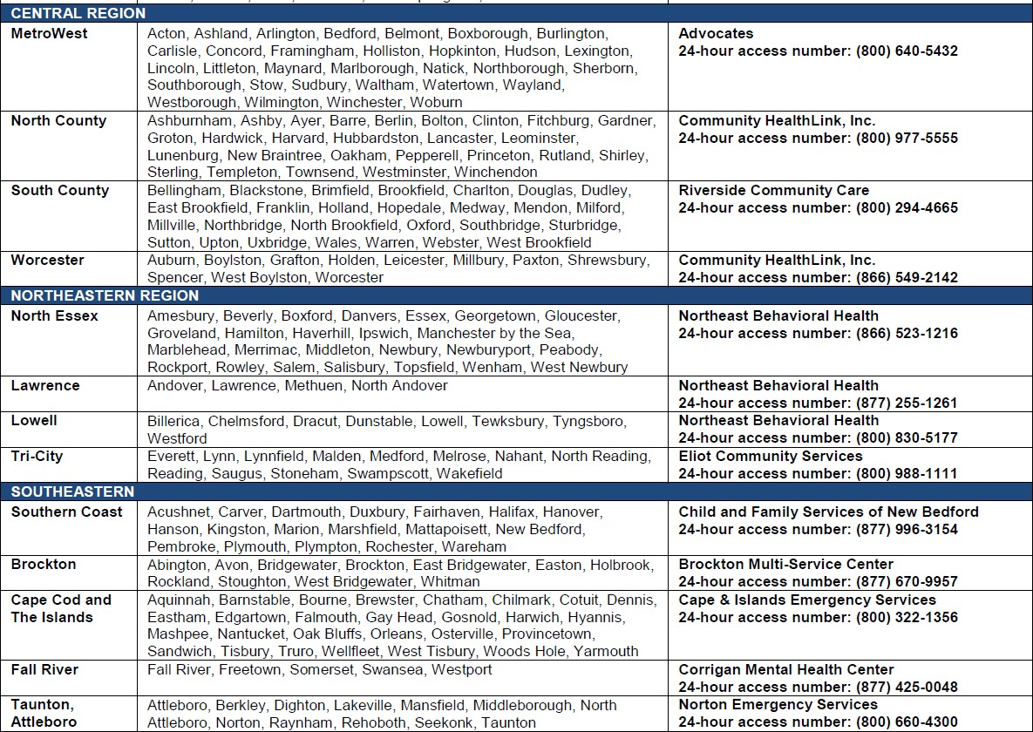

Samaritan Crisis Lines

24 Hour Telephone Befriending Service: (877)-870-HOPE. Or 877-870-4673
https://samaritanshope.org/our-services/247-crisis-services/
Samaritan volunteers offer callers acceptance and respect in a comforting and understanding manner. In addition to supporting depressed, lonely and suicidal callers. This program also supports those calling with concerns for others.

IM Hear For Adolescents
https://samaritanshope.org/im-hear/

Reach Us by Text 24/7 . Send a Text to 1.877.870.4673

Being a teenager isn’t easy. We know, we’re teens too. And we’re here to chat about anything and to support you through a tough time. IM Hear_ is the teen-to-teen online instant messaging program of our Befriending Services. It is dedicated specifically to providing online emotional support and to the prevention of suicide among teens. This teen online chat service provides confidential peer support and understanding to teens who are struggling with feelings of depression, loneliness and stress. Trained volunteers (ages 15-18) will operate Monday through Thursday from 6pm – 9pm.

IM Hear For College-Age Young People
http://samaritanshope.org/im-hear-college/

Lifeline Crisis Chat

1-800-273-8255: English
1-888-628-9454: Spanish
Lifeline Crisis Chat is a service of the National Suicide Prevention Lifeline. Available 24/7

Crisis Text Line https://www.crisistextline.org/
Text: 741741

Text from anywhere in the USA to text with a trained Crisis Counselor.
For more details: https://www.crisistextline.org/texting-in

Resources For Mass LGBTQ+ YOUTH
http://www.tinyurl.com/LGBTQ-covid-resources

Mental Health Support

DMH: Young Adult Service Guide
https://www.mass.gov/handbook/young-adult-resource-guide

For mental health clients that are not experiencing a mental health emergency but would benefit from having a check in phone call, they can access DMH sponsored warm- lines. These are typically peer run and can offer general support. The area Warm-Lines can be found here: https://www.mass.gov/info-details/dmh-young-adult-resource-guide-hotlines-warm-lines-and-young-adult-council-meetings#warm-lines-

Virus Anxiety is a project by SHINE. Resources for anxiety and your mental health in a global climate of uncertainty
https://www.virusanxiety.com/

National Distress Hotline: 1-800-985-5990
https://www.samhsa.gov/find-help/disaster-distress-helpline

A 24/7, 365-day-a-year, national hotline dedicated to providing immediate crisis counseling for people who are experiencing emotional distress related to any natural or human-caused disaster.

The Relational Center is offering Zoom conference links to daily online video chat support groups that are free and open to the public. http://www.relationalcenter.org/onlinesupport/

Mindfulness/Meditation
https://mindfulness-solution.com/: Mindfulness offers a path to well-being and tools for coping with life’s inevitable hurdles.
https://www.health.harvard.edu/mind-and-mood/breath-meditation-a-great-way-to-relieve-stress: Article: Breath meditation: A great way to relieve stress
https://ggia.berkeley.edu/practice/mindful_breathing: Steps and audio of guided meditation, produced by UCLA’s Mindful Awareness Research Center (MARC).
https://mindfulness-solution.com/downloadmeditations/

Homeless/Housing/Supports for Teens & Transitional Age Youth

Bridge Over Troubled Waters: https://www.bridgeotw.org/
617-417-1620
Shelters, transitional housing, advice, help and suggestions of where to go.

The Haven Project. https://havenproject.net/
(781) 913-5738 (Call to make sure they are still open during Covid19)

A Drop-In Center and Support Service Program for Ages 17-24

Lynn Drop-In Site:
57 Munroe St. Lynn, MA

Salem Drop-In Center Site:
Lifebridge North Shore
54 Margin St. Salem MA

At the Drop-In Centers: Basic Needs Provided
They evaluate individual situations and provide a space for the youth to get off the street and recover. They provide hot meals each evening and unrestricted access to a food pantry, and offer basic needs items including clothing, backpacks, and hygiene items, access to a shower and laundry on-site, and funds for transportation. They also help clients access health care, emergency phones, food stamps, and provide ID’s. Available by phone Monday – Saturday by phone at (781) 913-5738 to answer questions about the program and to offer emergency assistance to young adults.

The Home For Little Wanderers: http://www.thehome.org/site/PageServer

Transitional Services Teens and Young Adults:
YARN: http://www.thehome.org/site/PageServer?pagename=YARN

Roxbury Village: http://www.thehome.org/site/PageServer?pagename=roxburyvillage

Somerville Village: Support for Higher Education: http://www.thehome.org/site/PageServer?pagename=roxburyvillage

Peer Mentors: http://www.thehome.org/site/PageServer?pagename=collaborative_peermentor

Waltham House: Residential Group Home for LGBTQ youth ages 14 -18
http://www.thehome.org/site/PageServer?pagename=programs_waltham_house
Phone: (781) 647-9976
Waltham House offers residents a safe environment to live while they prepare for family reunification, independent living and future self-sufficiency.

Dial/Self: http://dialself.org/
(413) 774-7054

A community-based non-profit agency that has been serving the youth and communities of Western MA in Franklin, Hampshire and Hampden Counties and the North Quabbin Region.

Transitional Housing

LGBTQ Housing First

Teen Housing (Greenfield, Northampton, Orange)

Luk, Inc. Adolescent/Youth Adult Services Transitional Living Programs
https://www.luk.org/services/foster-care-respite-mainmenu-62/young-adult-main
508-762-3200 Or call Toll-Free 800-579-0000

TLP: For young people between the ages of 16 and 21 throughout Worcester County who are homelessness or at risk of homelessness.

Maternity Group Home is available for pregnant and parenting young people between the ages of 16 and 21 throughout Worcester County who are homeless or at risk of homelessness.

Basic Center Program provides 24/7 access to emergency shelter for youth under 18 years old throughout Worcester County who are runaway, homeless or at risk of homelessness

National Runaway Safeline (NRS) https://www.1800runaway.org/youth-teens/

NRS has a database of resources, including shelters, across the country that we continually update. When you contact us, either by hotline, chat, or email, we can work toward locating an open bed in a shelter in your area. When contacting shelters via telephone, a frontline staff member will be happy to stay on the phone and serve as an advocate for you if you want him/her to. CALL: 1-800-RUNAWAY; TEXT: 66008

Justice Resource Institute (JRI): Transitional Programs:
https://jri.org/services/educational-and-residential/transitional-living/stepping-out

https://jri.org/services/educational-and-residential/transitional-living/rediscovery

https://jri.org/services/educational-and-residential/transitional-living/evolution

Internet/Communications

Lifeline Services: Lifeline is a government benefit program that provides a monthly discount on one communications service from a certified Lifeline service provider.
https://www.mass.gov/how-to/apply-for-a-discounted-communications-service-through-the-lifeline-program

Internet Essentials: Affordable Internet at Home for Eligible Households
You may qualify if you are eligible for public assistance programs such as the National School Lunch Program, Housing Assistance, Medicaid, SNAP, SSI, and others.
https://internetessentials.com/

Charter/Spectrum: 2 Free months
Charter will offer free Spectrum broadband and Wi-Fi access for 60 days to households with K-12 and/or college students who do not already have a Spectrum broadband subscription and at any service level up to 100 Mbps.
https://corporate.charter.com/newsroom/charter-to-offer-free-access-to-spectrum-broadband-and-wifi-for-60-days-for-new-K12-and-college-student-households-and-more

Comcast/Xfinity 2 Free Months Internet
https://www.internetessentials.com/covid19#thingstoknow&all_CanIdisconnectatanytime

Expanded Internet Service Now Available from Many Carriers

Recently, many of the top telecommunications companies took measures to alleviate some of the burden of the current need for remote communication. Though most aren’t going so far as to waive home Wi-Fi bills, depending on your provider you may be receiving added benefits to your existing plan. You don’t need to do anything special to receive these benefits; most were rolled out this past weekend. These expanded services can be particularly helpful for our clients, who may have very limited phone/internet plans.
- Comcast, AT&T, and Charter customers can receive free access to their many public wi-fi hotspots for the next two months. All you need is a valid account.
- If you do not currently have a Charter subscription, they are offering free broadband to households with K-12 and college age children.
- Comcast and AT&T are also lifting data caps for smartphone plans.
- Verizon has announced a moratorium on late fees and disconnections.
- T-Mobile and Sprint proving unlimited smart phone data to all current customers.
- Cox is increasing speeds on low cost broadband plans.
- Assurance wireless by Virgin mobile offers a free phone and subscription plan to qualifying candidates. Enrollment is available to individuals who qualify based on federal or state-specific eligibility criteria, including those on certain public assistance programs, like MassHealth or Supplemental Nutrition Assistance Program (SNAP). Individuals may also qualify based on household income.
For more information please follow any of the links below:
Comcast: https://corporate.comcast.com/covid-19
AT&T: https://about.att.com/pages/COVID-19.html
Charter: https://corporate.charter.com/newsroom/charter-to-offer-free-access-to-spectrum-broadband-and-wifi-for-60-days-for-new-K12-and-college-student-households-and-more
Verizon: https://www.verizon.com/about/news/update-verizon-serve-customers-covid-19
T-Mobile: https://www.t-mobile.com/brand/ongoing-updates-covid-19
Sprint: https://www.sprint.com/en/landings/covid-19.html
Cox: https://www.cox.com/residential/internet/connect2compete/covid-19-response.html
Assurance: https://www.assurancewireless.com/

Free Online Learning

- Scholastic Learn At Home
  - https://www.scholastic.com/teachers/teaching-tools/articles/resources/scholastic-learn-at-home--free-resources-for-school-closures.html#
- Go Noodle
  - https://www.gonoodle.com/
- Khan Academy
  - https://www.khanacademy.org/
- Prodigy Math
  - https://www.prodigygame.com/
- DuoLingo
  - https://www.duolingo.com/
- Mystery Science
  - https://mysteryscience.com/
- TED-Ed
  - https://ed.ted.com/
- PBS Kids
  - https://pbskids.org/
- PBS Learning Media
  - https://mass.pbslearningmedia.org/
- TIME for Kids
  - https://www.timeforkids.com/
- Learn from Home
  - https://docs.google.com/document/d/1SvIdgTx9djKO6SjyvPDsoGlkgE3iExmi3qh2KRRku_w/mobilebasic
- Virtual Learning Resource Center
  - Free online resources that has 20 days of lessons for grades PreK to 9th grade
  - https://classroommagazines.scholastic.com/support/learnathome.html
- Google Arts & Culture
  - https://artsandculture.google.com/partner?hl=en
  - Access digital tours from over 500 museums from around the world
- Massachusetts Historical Society
  - https://www.masshist.org/teaching-history/?goto=teaching-history
- Free School artist biographies on youtube
  - https://www.youtube.com/watch?v=qv8TANh8djI&list=PLXB5R79dmFB6HpWbgpF8-3aXPqVb_rbj5
- NASA Kids Club
  - https://www.nasa.gov/kidsclub/index.html
- Starfall (Free website to teach kids grade k-3 to read)
  - https://www.starfall.com/h/

