MyGideon: Instructions for CAFL Users
MyGideon is a national, member-only resource website for public defense professionals. CPCS is one of several member organizations on MyGideon. The CAFL page features training materials, sample motions and memos, practice tools, community resources, and more. The content is organized by topic. All CAFL practitioners have a MyGideon account.
Access to CPCS pages is strictly limited to users authorized by CPCS. By signing in to MyGideon, all users agree to maintain the security of the site and to refrain from sharing user identification and/or passwords with anyone.

As an authorized CPCS user, you have access to all CPCS practice area pages. You do not have access to sites and pages created by other organizations solely for their members, nor do their members have access to CPCS pages.

This site will always be a work in progress. There may be changes to the appearance of the site and organization of material as our practice evolves to respond to new developments and challenges. Publicly available information will remain on the CPCS website at www.publiccounsel.net.
To access MyGideon:
- Go to https://www.mygideon.org.

- Enter your username and password, and then select “Sign In.”
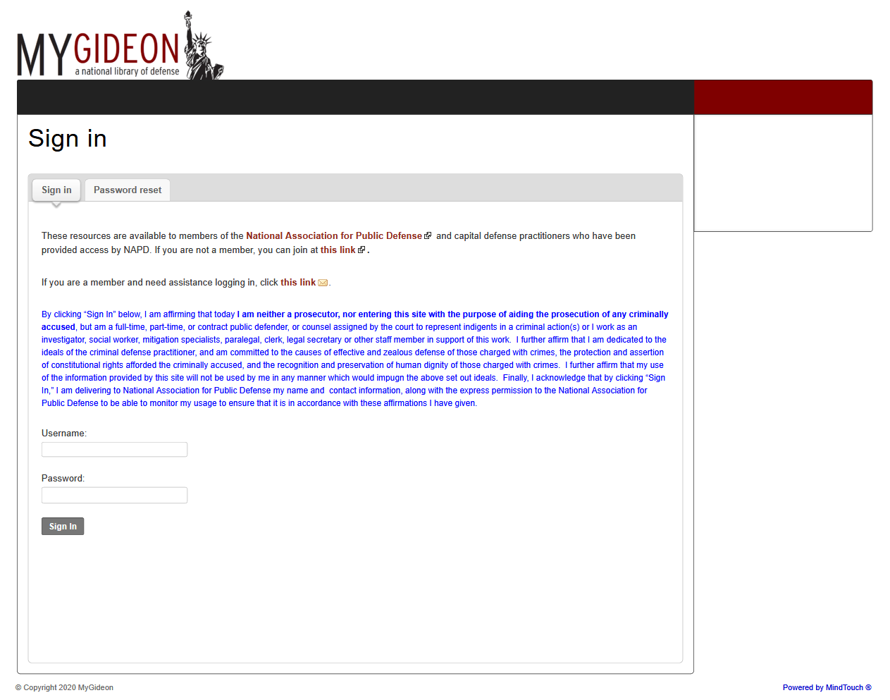

If you are a CAFL staff attorney, your username should be your full name, initials capitalized and a space between your first and last name. For example; if your full name is Elizabeth Smith, then your username is Elizabeth Smith.
If you are a private bar attorney, your username should be the full name you use for CPCS billing purposes, separated by spaces. For example; if the name you use for CPCS billing is Elizabeth A Smith, then your username is Elizabeth A Smith.
If you need to reset your password, please select the “password reset” tab on the sign in screen, then enter your username. You will receive an e-mail with password reset instructions. Please note that the e-mail will be from no-reply@mindtouch.us, not MyGideon. If you don’t receive it, please check your spam and junk folders. If you find the e-mail from MindTouch there, please make sure you mark it as “not spam” or “not junk” to ensure future e-mails are delivered to your inbox.
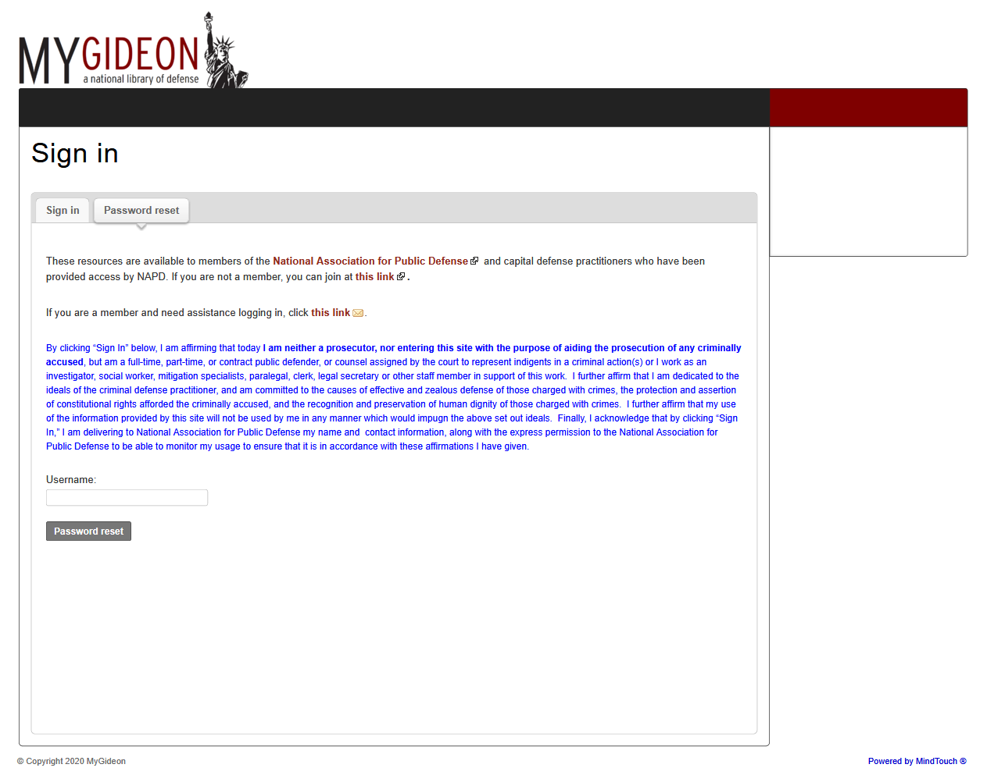

- Select “Massachusetts CPCS” from the menu options on the left side of the page.

- Select “Children & Family Law Resources.”

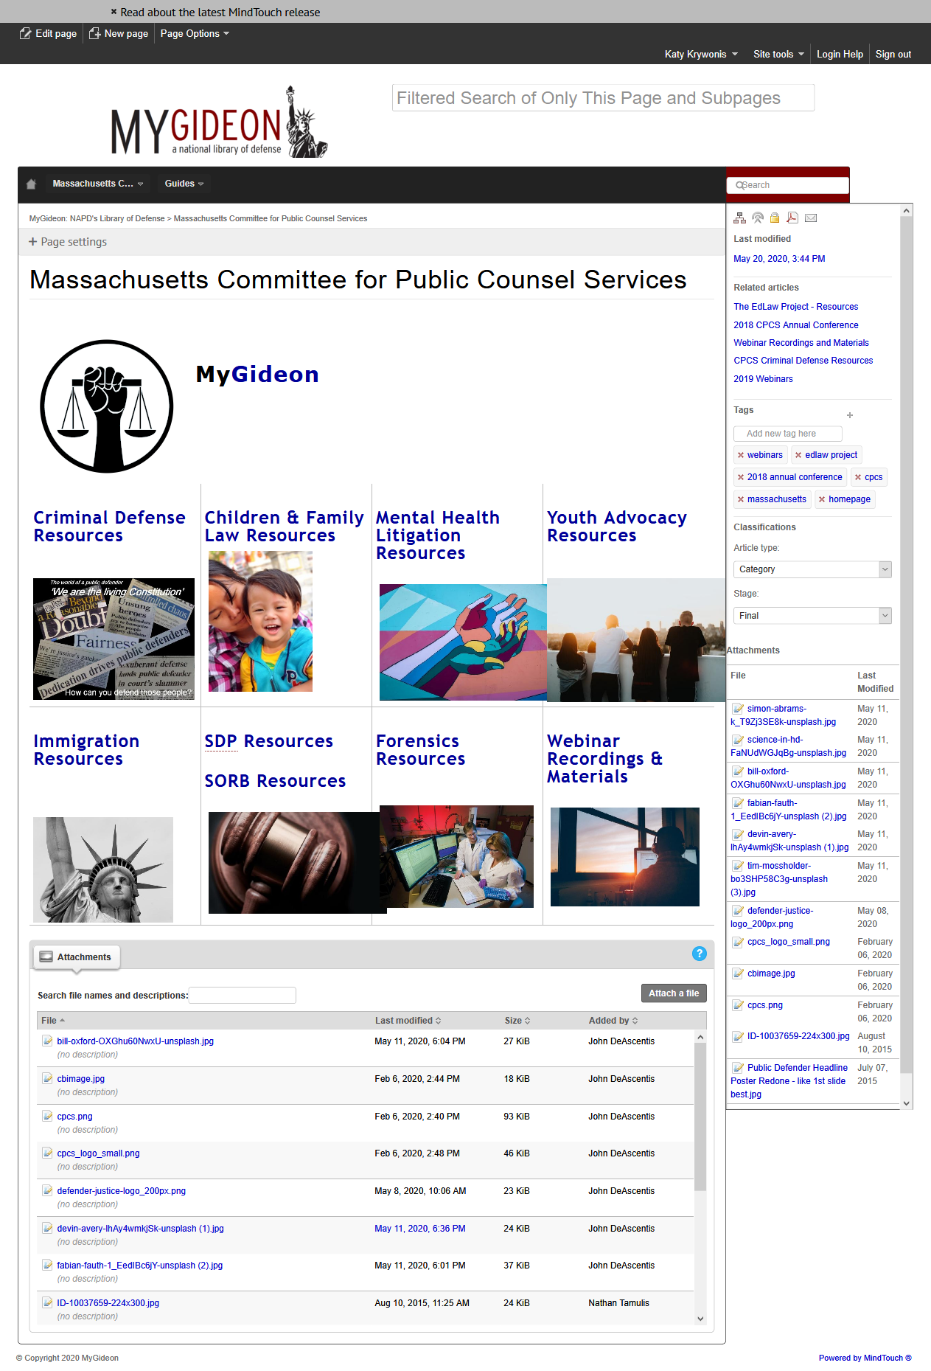
- To access CAFL COVID-19 resources, select “COVID-19 Resources.”

