Committee for Public Counsel Services
Children and Family Law Division

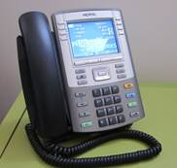
Telephone Interpreter Services for Limited English Proficient Clients

Our private panel attorneys can access telephonic interpreter services through Certified Languages International (CLI), a vendor which will bill CPCS directly. Although this service is not designed to replace in-person interpreter services, sometimes you need immediate assistance to provide information to a client (or witness) or to receive information from a client (or witness). All CLI interpreters are sworn to confidentiality, neutrality, and the Interpreter Code of Professional Ethics.

Here’s how: Dial 1-800-CALL-CLI. When the operator answers, tell them: Whether you need a third-party dial-out, your customer code is 467185, you are calling from Committee for Public Counsel Services, the language you need, your BBO Number, NAC Number, Docket Number and your Last Name.

Staff attorneys who need assistance with accessing phone interpreters should consult their supervisor.

